HPC Community Forum, 22 Sept 2022
  - Meeting Notes, S. Moffatt
The following notes are taken from the meeting presentation pack due to my absence from the meeting

General Progress
- The first stage of the third level for the outer containment wall was completed on the 25th August, involving a 27-hour pour with four pumps working to deliver the 4.5m high, 1.3m thick circular wall
- Over the rest of 2022, the internal containment structures will grow towards the 19.5m level with the completion of the final wall.
- Unit 1 liner ring 3 was lifted out of Bunker 6 on 12 August. This is the last Liner Lift before Dome Lift.
- Abnormal loads have been moving along the C182 from Combwich. Further deliveries are planned to be halted, pending completion of the final improvements at Combwich Wharf. The notification system is working well; inform HPC if anyone is not being informed that should be.
- Floating cranes have lowered the last of six enormous tunnel heads the cooling water system to the seabed. The final 5,000t concrete structure was towed out around 55km into the channel to meet two floating heavy lift cranes. The cranes with a combined lifting capacity of 7,300t then worked in tandem to place the cooling water head structures onto the seabed.

Planning and Permits

Proposed HP shared use cycle path (Combwich to Hinkley Point)
Note: there are public consultation meeting and drop-in events planned:
- 27th Sept 2022 Otterhampton Village Hall, 1pm to 8pm
- 6th October 2022 Stogursey Victory Hall, 3pm to 7pm
The Hinkley Point C project is considering a proposal to develop a 9.3km shared use cycle path running from the village of Combwich to Hinkley Point A, B and C power stations The new route would be open for public use and will be entirely funded by the Hinkley Point C project and, for the majority of the route, would look to resurface existing paths.
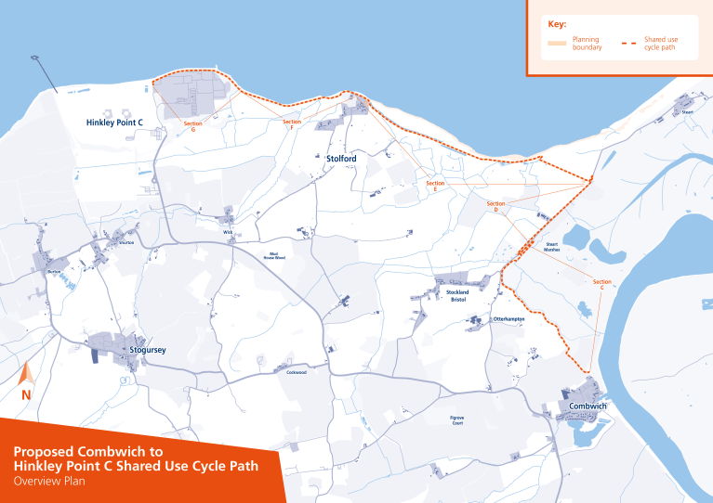

Acoustic Fish Deterrent
Following an appeal, the Secretary of State for the Environment, Food and Rural Affairs ruled against an application by HPC not to install one of three fish protection measures that were originally proposed. The acoustic fish deterrent is meant to deter fish that can detect sound from entering the cooling water intakes. HPC is now looking at this decision in detail to consider a response.

Environment Agency consultation on Radioactive Substance Regulations (RSR Permit)
The EA has conducted its consultation on variations to HPC’s RSR permit and a decision is expected soon.

Proposal for the use of Pontins (Brean Sands)
Discussions are under way with the owners of Pontins and Sedgemoor to house 900 people at Pontins Brean holiday camp. This would be during peak construction only and would be for around 3 years. Pontins is the nearest viable location available and is being considered as the existing campus cannot be further expanded.

ONR Reporting Q1/2 2022
- Routine and an un-announced inspection were carried out during this period
- ONR issued a License Instrument in May for the delivery of the first nuclear steam supply system component, a reactor pump casing, onto the site.
- ONR were made aware of a fire on site involving scaffold boards outside Reactor 1. Increased oversight of fire safety management is being carried out with consideration of other enforcement.
- Formal investigation will start on an event on site that resulted in a worker sustaining injuries due to a rebar mesh wall falling.

Date of next meeting: Thursday 19th January at 6pm

