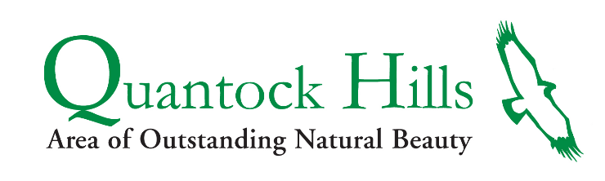

PRESS RELEASE
09 March 2021

---Begins---

Quantock Farmers ask ‘Please do not feed the ponies’

Since the start of the Coronavirus pandemic there has been an increase in people feeding the ponies on the open hilltops of the Quantocks. These ponies thrive on the grasses, heathers and plants on the hilltops and do not need extra food.

Some horses have special dietary considerations and can be intolerant to foods such as carrots and apples and cannot have too much sugar. Giving them “sweets and treats” can result in stomach ulcers, which are very painful, and colic which can kill them. Many fruit and vegetables may seem like “healthy” or “normal” horse treats, but they are not suitable for many horses including the ponies which graze the Quantocks.

As many of these ponies roam wild over the open hills people are unable to know how many “treats” they have been fed and people are making the mistake of saying “just one won't hurt”. A further issue of feeding the ponies is that they associate people and cars with food. They become more tolerant and will actively approach people and cars which increases the risk of people being bitten or kicked or the ponies being injured by vehicle collisions.

Ranger Andy Stevenson said, “Although they are beautiful to look at, the ponies are pretty wild and certainly not pets so keeping a little distance from them and appreciating them from a far is the best for everybody's wellbeing”.

----ends------

Notes to editors:

Contacts:

Amanda Sampson (Communications & Support Officer) asampson@somerset.gov.uk
Quantock Hills AONB Service, Fyne Court, Broomfield, TA5 2EQ

Photos:

Photo – Ponies in the early light (copyright) Quantock Hills AONB Service

About the Quantock Hills AONB Service:

The Quantock Hills Area of Outstanding Natural Beauty (AONB) was the first to be designated in England in 1956. An Area of Outstanding Natural Beauty (AONB) is exactly what it says it is: a precious landscape whose distinctive character and natural beauty are so outstanding that it is in the nation's interest to safeguard them.

The following statements form the Quantock Hills Vision; they describe the AONB we would like to see in twenty years’ time.

- The distinctive and beautiful character, geology and diversity of the AONB landscape is conserved, encompassing Quantock heaths, woods, farmland, parkland, coast and villages.
- Biodiversity is protected and enhanced through positive management and increased connectivity between key wildlife habitats across the whole Quantock landscape and beyond.
- The Quantock historic environment is protected and understood in detail and distinctive man-made elements are retained and conserved both the ordinary and the exceptional.
- Design takes account of the Quantock landscape and respects and reinforces local character and scale in both redevelopment and new development affecting the AONB.
- High-quality access is available across the AONB through a well maintained network of paths and open access areas.
- Productive farming and forestry businesses that support and enhance the intimate scale, historic character and biodiversity of the Quantock Hills.
- Sustainable levels of Quantock tourism and recreation maintain public enjoyment of the AONB and contribute to the local economy without harming landscape, historic environment, biodiversity or tranquillity.
- Quantock communities and pride of place are strong and involvement of local people and volunteers is extensive in managing change and protecting the area.

There are 40 AONBs in England and Wales (35 wholly in England, 4 wholly in Wales and 1 which straddles the border). Created by the legislation of the National Parks and Access to the Countryside Act of 1949, AONBs represent 18% of the Finest Countryside in England and Wales. Their care has been entrusted to the local authorities, organisations, community groups and the individuals who live and work within them or who value them.

The Quantock Hills AONB Service is supported and funded by Somerset County Council, Defra, Sedgemoor District Council and Somerset West & Taunton Council.

Ponies on the Quantock Hills:
- Quantock Common is a large block ,over 1,800Ha, of unenclosed heath and woodland on the hilltops of the Quantock Hills. It is a special habitat and is protected as a Site of Special Scientific Interest (SSSI). Quantock Common is managed by the active Commoners (local farmers who have rights of Common), landowners and the AONB Service. Part of the required management is grazing by sheep, ponies and cattle. This mix of grazing promotes the different heathland species such as heathers and bilberry.
- The majority of ponies that graze the unenclosed hilltops of Quantock Common are owned by farmers / landowners who have rights of common to graze animals on the common.
- The farmers / landowners are known as ‘Commoners’ as they are exercising their rights of common. They regularly inspect the ponies and any issues reported to the AONB Service are passed onto the relevant farmer / landowner to rectify.
- If people see a pony they believe is in distress or hurt they can report it to the AONB Service, who will ensure it is communicated to the most appropriate farmer / landowner.
- Other locations also have grazing stock such as Lydeard Hill and Cothelstone Hill. These are not commons and the ponies that graze these hills are owned by the landowners.

