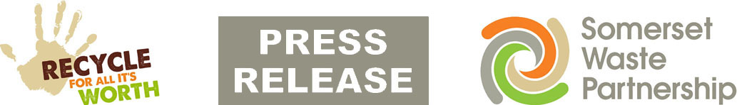

For Immediate Release
30 September

Recycle More making a massive impact

Two years after its launch, the staggering impact of Recycle More is becoming clear.

The roll-out of expanded Somerset Waste Partnership (SWP) kerbside collections began in Mendip in October 2020, adding plastic pots, tubs and trays and other new items.

Figures show that with Recycle More the weight of waste in rubbish bins has fallen by around 20% while the amount of plastic collected has nearly doubled.

And since the new service started, huge amounts of new materials have been collected:
- 174 tonnes of small electricals
- 97 tonnes of cartons (including Tetra Pak)
- 27 tonnes of household batteries

In 2019-20 the average monthly weight of plastic collected in Somerset was 270 tonnes. So far in 2022-23 it has been a massive 518 tonnes – an estimated 10million pieces, every month.

Recycle More is now in place for all residential homes in the county, with the roll-out to Sedgemoor and West Somerset finishing in July.

In October, collections from Somerset schools will be expanded as the final part of the award-winning initiative.

The scale of the Recycle More effect is being revealed during Somerset Recycling Week, a week dedicated to sharing recycling information, guidance and good practice.

Mickey Green, SWP Managing Director, said: “We want great recycling to be part of everyone’s daily routine and in the Somerset DNA.

“These figures show how warmly residents have embraced Recycle More, and that has helped our recycling rate reach new heights. We can all be proud of what’s been achieved so far, but there’s still lots more we can do”.

In 2021-22 Somerset recycled or reused nearly 150,000 tonnes, saving 133,000 tonnes of carbon – the same as taking 51,000 cars off the road for a year.

An impressive 97.2% of material stayed in the UK to be turned into new products and packaging, including 99.4% of plastics.

The full Somerset Recycling Tracker can be found on the SWP website and shows in detail what happened to every tonne collected in the county.

To keep up to date with waste services, sign up for the SWP e-newsletter at somersetwaste.gov.uk or follow somersetwaste on Facebook or Twitter.

[ends]

Notes to Editors

Somerset Waste Partnership is the local authority team managing waste services for all Somerset councils.

Media contacts:
Nick Cater, Senior Communications Officer Nick Cater,
Nicholas.Cater@somersetwaste.gov.uk

Mark Ford, Head of Communications and Engagement, 07977412198 mford@somersetwaste.gov.uk

