Rural Affairs Unit

EXTRAORDINARY RURAL AFFAIRS FORUM JUNE 2022

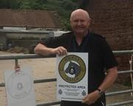

Farm Watch
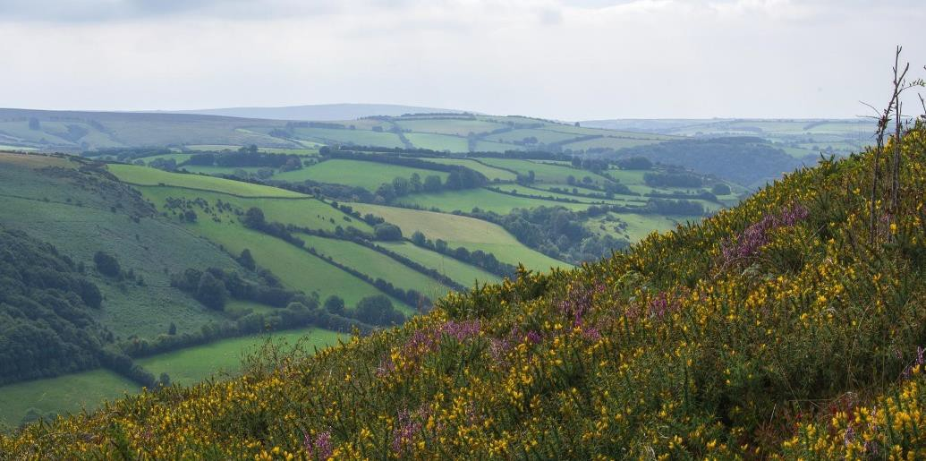
Did you know, rural crime can be reduced using Watch schemes?

Concerns for increased farm thefts
We are aware there has been a concerned and perceived fear of an increase in theft of fertiliser nationally since the conflict in Ukraine.

The Avon and Somerset Rural Affairs Unit would like to reassure our rural communities that, at this time, we have had no significant increase in reports of theft of fertiliser.

We would like to take this opportunity to highlight the most likely items to be stolen from the farming community, and then provide some advice on how to target, harden and prevent property from being stolen.

There are also measures which can be implemented which will increase the likelihood of property being located and returned to the rightful owner.

MOST LIKELY TO BE STOLEN
Trailers, plants, machinery

LESS LIKELY TO BE STOLEN
Fences, livestock, firewood, fuel

UNLIKELY TO BE STOLEN
Feed, fertiliser, cables
By using your knowledge and awareness of what is happening on and around your land, you can help to reduce crime and deter criminals.

We are encouraging all our farming communities within the Avon and Somerset area to sign up to our successful rural watch groups – Farm Watch and Horse Watch – which are both free to join!

The schemes are a partnership between police and communities to reduce crime and provide an early warning system for the farming and equine communities. Suspicious people and vehicles can quickly be reported to the police and we can send live updates, alerting members of theft or criminal activity in the area.

Get involved
Alert messages are sent to members by text, email and landline voicemail.

Use the free reporting service for members by texting 07492 888109.

However, when a crime is in progress, do not attempt to confront the suspect. Call 999 immediately and wait for the police.

You can join the watch schemes by emailing ruralandwildlifeunit@avonandsomerset.polic e.uk

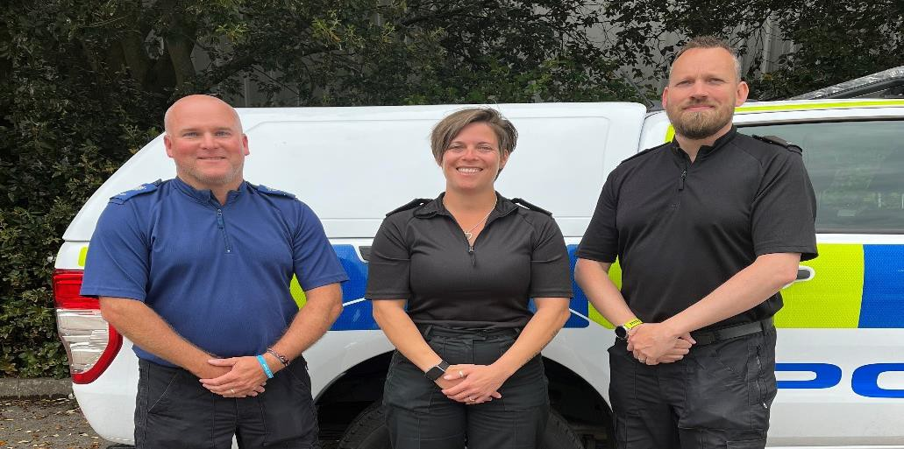
PROTECTING RURAL PROPERTY WHAT CAN I DO?

Property marking

Keep a comprehensive record of your property including makes, models and serial numbers.

This can help items to be recovered and allowing us to reunite property with the rightful owner.

Consider taking photos of your property and everything is registered on the Immobilise Property Register.

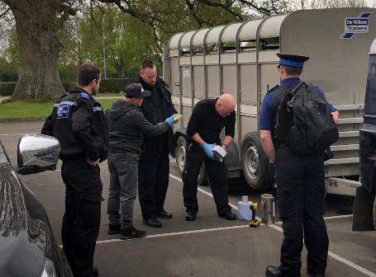
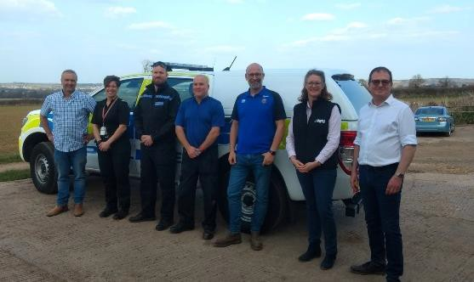
Livestock, equipment and tack
Carry out regular counts on all your livestock, maintaining concise records of your stocks and tag numbers.

Farm and plant vehicles
- Fit tracking devices on your agriculture and plant vehicles. You can also mark them using security or forensic markings. Check with your insurance provider as some will offer discounts once a tracker is fitted.
- Lock your vehicles and plant in secure outbuildings or containers.
- Record vehicle and machinery serial numbers and take photographs for reference.
- Secure your vehicle (quad and ATVs) using suitable locking devices and fixed ground anchors, secured to the floor using the correct gauge in security chains and padlocks.
- Protect your vehicles, trailers and plant by registering them on the Immobilise Property Register.
- Fit a key safe, so keys to vehicles are kept in a secure place.
- Remove all GPS from your machines when not in use and store securely.
- Ensure all trailers are fitted with a good standard wheel clamp and hitch lock.

Make a note of any distinguishing marks or features on your livestock.

Consider the use of wildlife cameras if you keep your livestock in isolated areas.

Mark all tack with your postcode using metal punches, engraving tools, or forensic marking.

Photograph your tack, keep a comprehensive list of all items.

Fuel tanks
Consider where your fuel tank is located, avoid placing it in an isolated location.

Keep a record of the amount of fuel your tank contains.

Secure your fuel tank to avoid tampering and theft of fuel.

Advice
We recommend the use of security products which are compliant with the appropriate British Standards.

In addition, look for products which carry the Sold Secure or Secured by Design accreditation. These products have been tested and proven to resist a considerable level of attack.
www.soldsecure.com www.securedbydesign.com

Get in touch
In an emergency, call 999.

For non-emergency matters, call 101 or report online via www.avonandsomerset.police.uk/rep ort

To report crime anonymously, contact Crimestoppers on 0800 555 111 or visit www.crimestoppers- uk.org

Consider installing a tank alarm and an anti-siphon device.

Follow us on social media @ASPoliceRuralAffairs
Rural Crime Affairs
Unit – Avon and Somerset Constabulary

